TK-STAR GPS TRACKER

USER MANUAL

PREFACE

Thank you for purchasing the GPS tracker. This manual shows how to operate the device smoothly and correctly. Make sure to read this manual carefully before using this product. Please note that specification and information are subject to changes without prior notice in this manual. Any change will be integrated in the latest release. The manufacturer assumes not to be responsible for any errors or omissions in this document.

1. SUMMARY
Working Based on existing GSM/GPRS network and GPS satellites, this product can locate and monitor any remote targets by SMS or internet. The most advanced technology of GPS and A-GPS dual positioning.
Content | Specs.
Dim. | 50mm x 50mm x 20mm(1.96”*1.96”*0.78”)
Weight | 50g
Network | GSM/GPRS
Band | 850/900/1800/1900Mhz
GPS sensitivity | -159dBm
GPS accuracy | 5m
Time To First Fix | Cold status 45s  Warm status 35s  Hot status 1s
Car charger | 12—24V input  5V output
Wall charger | 110－220V input  5V output
Battery | Chargeable changeable 3.7V 1000mAh Li-ion battery
Stand by | 180hours
Storage Temp. | -40°C to +85°C
Operation Temp. | -20°C to +55°C
Humidity | 5%--95% non-condensing

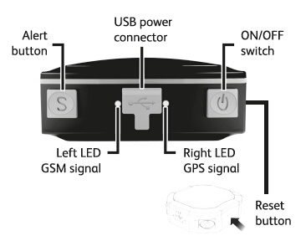

LED INDICATOR STATUS | MEANING
Left-GREEN-Continuously lit | No GPRS signal.
Left-GREEN-Flashing | GPRS communication established.
Center-RED-Not lit | Fully charged.
Center-RED-Solid red | Charging.
Right-BLUE-Continuously lit | Searching for GPS signal.
Right-BLUE-Flashing | GPS location successful.

2. INSTALLATION

2. 1 SIM-CARD INSTALLATION
Once the SIM card has been purchased and credit added, unscrew the tracker using the screwdriver to remove the 4 small screws in each corner.
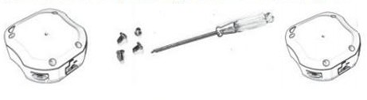
Then, insert the SIM card into the SIM card holder by push the metal piece forward and lifting it up, Place the SIM-card into the card slot, Press the metal piece back into its original position and push the metal piece back into place.

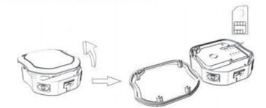
If you have purchased a MICRO SIM , you will need to use the Micro SIM adapter enclosed, like this:
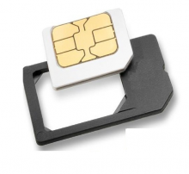
Ensure you place the SIM card with the chip face down and the right way round, clip the holder into place and re-screw up the unit.

2.2 USE THE GPS DEVICE
- Turn on the unit outdoors by pressing the “on/off” button until the indicator is on.
- For first use, please initialize the unit and restore it to default setting. (Please refer to 3.1 for instruction.)
- In 10 or 40 seconds, the unit will begin to work and acquire the GSM signals as well as the GPS signals. The indicator will keep flashing every 3 seconds when the unit has received the signals.
- When this unit receives GPS signals normally, you can use it and do any setting as the instructions of this manual.

2.3 EXPLANATION OF PARAMETERS/CODES IN SMS MESSAGE
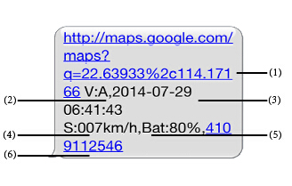

- Google Maps link: This is the link to the Google map showing the position of the tracker unit.When click the link, if a map is displayed, there is GPS information for the unit. If there is no may, there is no GPS information for the tracker.
- V:A/V: Indicates GPS signal. V:A indicates there is a GPS signal; V:V indicates there is no GPS signal.
- 2014-07-29 06:41:43 The date and time stamp when the unit last received a GPS signal.
- S: 007km/h: This indicates the last known speed of the unit.
- Bat:80% The approximate amount of battery charge remaining. The value is between 1 0%and 100%, with 100% being fully charged.
- 4109112546: The ID code of tracker device. This number is used for tracking website and the app.

3. SMS Tracking
- Call the SIM-card phone number in the device by other cell phone
- Receive a Google Maps link by SMS to your mobile phone
- Click on the Google Maps link
- Now it displays the position of device.
3.1 Command Instruction

INSTRUCTION | COMMAND | REPLY
Reboot the device | begin123456 | begin ok
Set authorized number | admin123456 phone number | admin ok
Cancel authorized number | noadmin123456 phone number | noadmin ok
Set SOS phone number | sos123456 phone number | sos number ok
Cancel sos number | nosos123456 phone number | nosos ok
SMS Track | G123456# | Google link
Set GMT time zone number | timezone123456 8  Timezone123456 -8 | time ok
Sleep by time (default mode-save much power,tracker will fall asleep in 5 minutes) | sleep123456 time | sleep time ok
Sleep by shock sensor(Suits for tracking on platform) | sleep123456 shock | Sleep shock ok
No sleep(tracker will continuou working) | sleep123456 off | sleep off ok
Switch to the NO GPRS mode(default mode) | Nogprs123456 | Nogprs ok
Switch to the GPRS mode(for tracking online ) | gprs123456 | gprs ok
Status Check | Check123456 | IP,APN,GPS, GSM,status

3.2 ONLINE TRACKING

3.2.1 Turn on GPRS function by sending comand “gprs123456” to the tracker, and set the apn for tracker, then online tracking will work .

APN information is from sim card carrier ,every sim card carrier has different APN information, there are two ways to find APN out: check sim card carrier on internet or put sim card into own cell phone to find check APN

3.2.2 COMMAND INSTRUCTION TO SET THE ACCES POINT NAME (APN)
NAME | INSTRUCTION | COMMAND | REPLY | FOR EXAMPLE
APN | Set new APN  ( old one will be replaced) | apn123456 content | apn ok | apn123456 apn
APN user | Set APN username | apnuser123456 content | apnuser ok | apnuser123456 user
APN password | Set APN password | apnpasswd123456 content | apnpasswd ok | apnpasswd123456 password
Switch to the GPRS mode | Open the GPRS | gprs123456 | gprs ok | gprs123456
Set Upload the frequency | Default 120 seconds | Upload123456 30 | Upload ok | Upaload123456 30

3.2.2 START ONLINE TRACKING

Note:must set apn at first

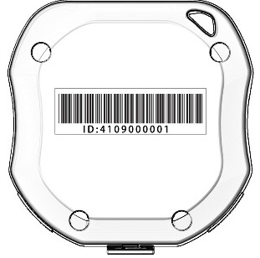

Platform : 2.tkstargps.net/

IMEI No. : On the back side of cover
Password: 123456

3.2.3 APPLICATIONS FOR ANDROID/iOS
Search “TKSTAR“ in the Apple App Store/Google Play
Store or Scan the QR Code to install the applications on
your cell phone.
Select “Log in by IMEI” on the
bottom of screen
Server: 2.tkstargps.net

IMEI : on the back side of cover
Password: 123456

Note:
When the device can't get GPS signal in one minute or in sleep mode, it will reply history position (V:V ); the device will send real time tacking information until it get GPS signal (V:A).

Make sure that all the symbol“+”in sms commends is just for quick understanding, which don’t need to
enter “+” in sms, and “space” means press the space bar button of the cell phone.

When the device location show different with map, there are two kinds of circumstances, 1.Device in sleep condition, 2 No GPS signal;Solution: Dial SIM Card Number in the Device, if only reply one SMS with "V:V", it means no GPS Signal; If reply one SMS, with "V:A", it means device in sleep model;
(Note: We advice use Shock Sleep Model when driving)

